Geometry: Using Geogebra to determine the volume of a 3D figure
Grades: 7-10

Important Vocabulary:
- Volume – The measure of the amount of space inside a solid figure
- Radius – The distance from the center of the circle and any point on the circle.

Important Formula:
$$Volume of a Cylinder: V={πr}^{2}h$$

- In Geogebra, click the view drop down tab at the top of the document and select 3D Graphics.
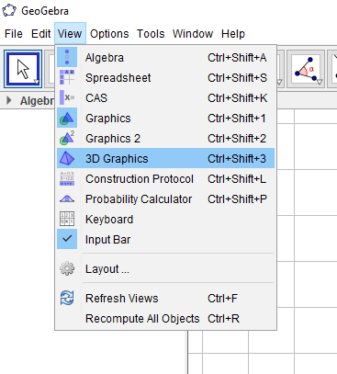

- Click on POINT, located under the picture of a point and the letter A:

  - Create two points on the z-axis by clicking the graph in the location the point is to be located, one at z = 0 and one at z = 6.

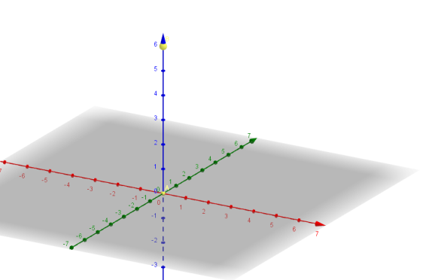

- Click on CREATE SLIDERS under the slider tab, and then click anywhere under the section titled Graphics.
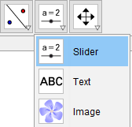

- Organize the sliders:
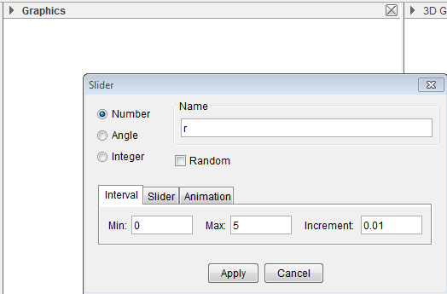
  - In the Name section, label the slider r.

  - Change the interval to say there is a Min: 0 Max: 5 and Increment: 0.01

- Using the two points, A and B, create a cylinder with a radius of r.

  - Click on the pyramid tab, located at the top left of the screen, and select CYLINDER.
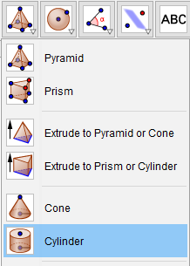

  - Draw a cylinder connecting points A and B.

  - When prompted, insert r for the radius of the cylinder.
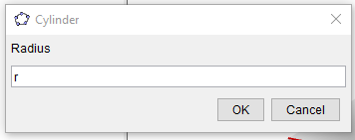

- Click on CREATE SLIDERS under the slider tab, and then click anywhere under the section titled Graphics.

- Organize the sliders:
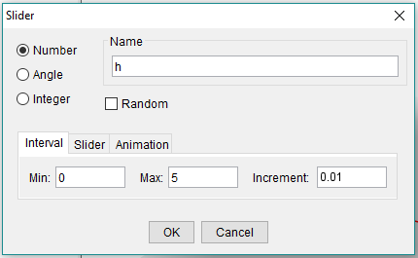
  - In the Name section, label the slider h.

  - Change the interval to say there is a Min: 0 Max: 5 and Increment: 0.01

- Insert the point C=(0,0,h) into the INPUT line.
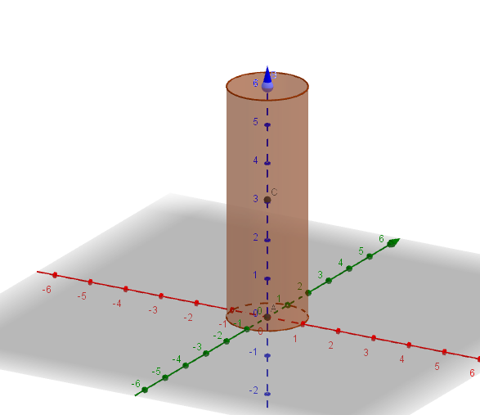

- Using the points A and C, create a cylinder with a radius of r.

  - Click on the pyramid tab, located at the top left of the screen, and select CYLINDER.

  - Draw a cylinder connecting points A and C.

  - When prompted, insert r for the radius of the cylinder.
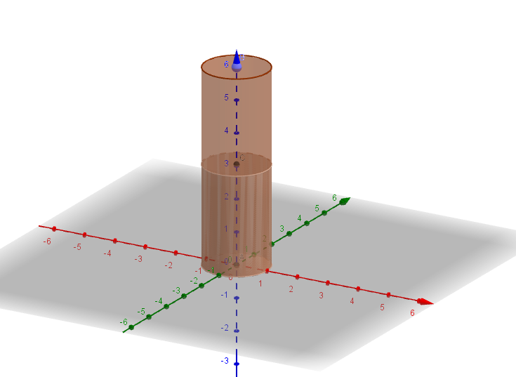
- Under the section titled 3D Graphics, turn off the plane and axis, by selecting the highlighted boxes.

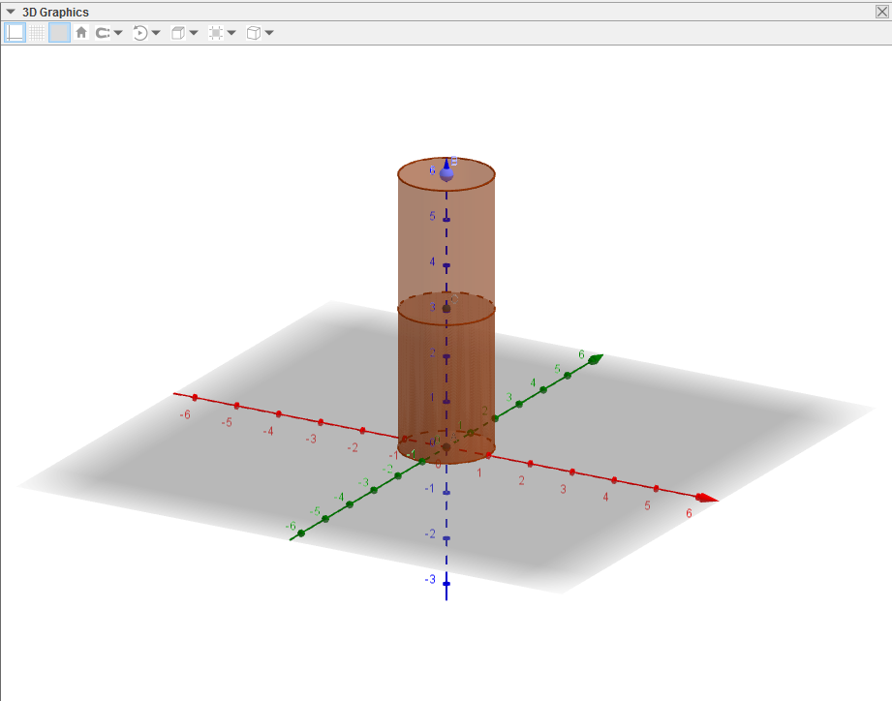

- Under the section titled Algebra, right click on the category points and click on SHOW OBJECT.

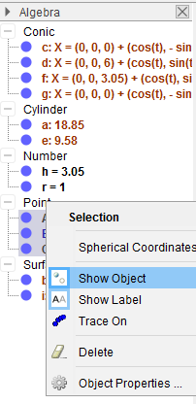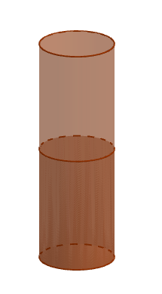

- Add Animation

  - Click the slider tab at the top of the page, select BUTTON, and then click anywhere under the section titled Graphics [You will repeat this step TWO times].
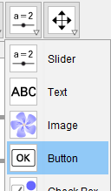

  - START button
    - Type START in the box labeled Caption

    - Insert StartAnimation[h] into the section labeled GeoGebra Script, this provides the information required to have the height of the shape change.

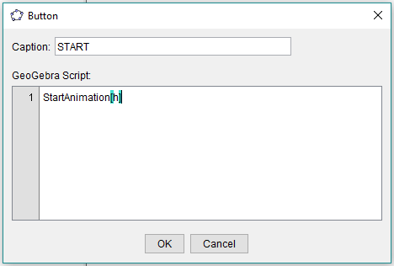

  - RESET button
    - Type START in the box labeled Caption

    - Insert StartAnimation[false] into the section labeled GeoGebra Script, this negates the information that the START button provides.

    - Press enter and insert h=0 into the section labeled GeoGebra Script.

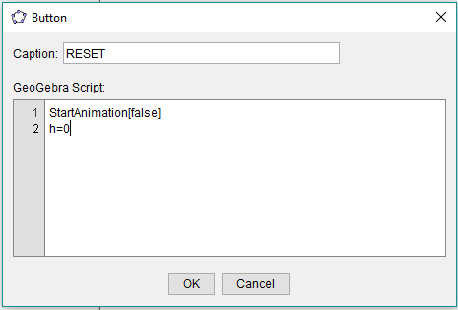

- Insert the formula V=r^(2)*pi*h into the INPUT line.

- Click the button tab at the top of the page, select TEXT, and then click anywhere under the section titled 3D Graphics.

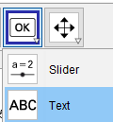

  - Use the text boxes to insert the volume of the figure into the 3D Graphics section.
    - Volume is represented by the letter V

    - Start by typing V= in the section titled Edit, then select the number represented by V under Algebra, Numbers
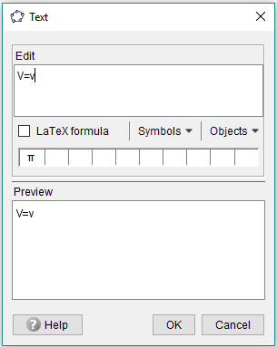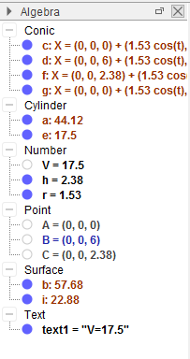

- We want to adjust the colors and fonts so that they can be seen clearly.
  - Under the Algebra section, right click on the cylinder and select Object Properties.
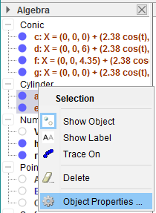

  - Fix the color of the two cylinders and the text (Make sure that the cylinder AB is lighter in color than cylinder AC), using the COLOR tab.
    - Cylinder AB is represented by the variable a
    - Cylinder AC is represented by the variable e
    - The Text V=V is represented by text1

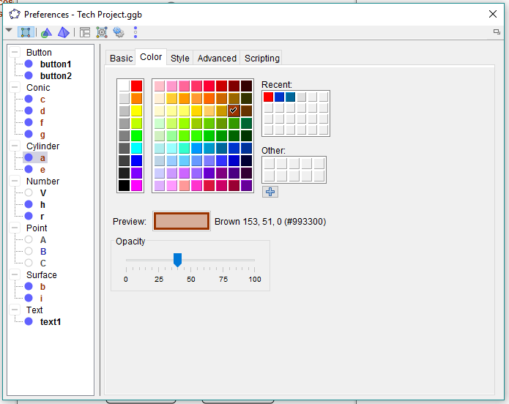

  - Fix the font of the text using the TEXT tab.

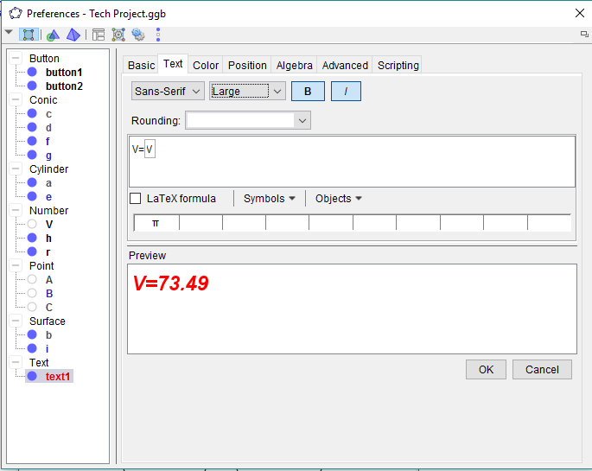

- We want to reposition the TEXT box, so that the text changes positions as cylinder AC moves.
  - Under the Algebra section, right click on text1and select Object Properties.

  - Under the POSITION tab, unselect the “Absolute position on screen” box. After unselecting the box, insert the boundary C+(-1,0,0) for the starting point and press ENTER.

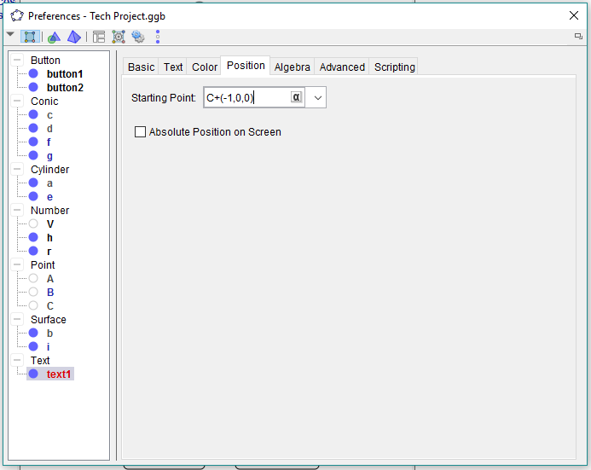

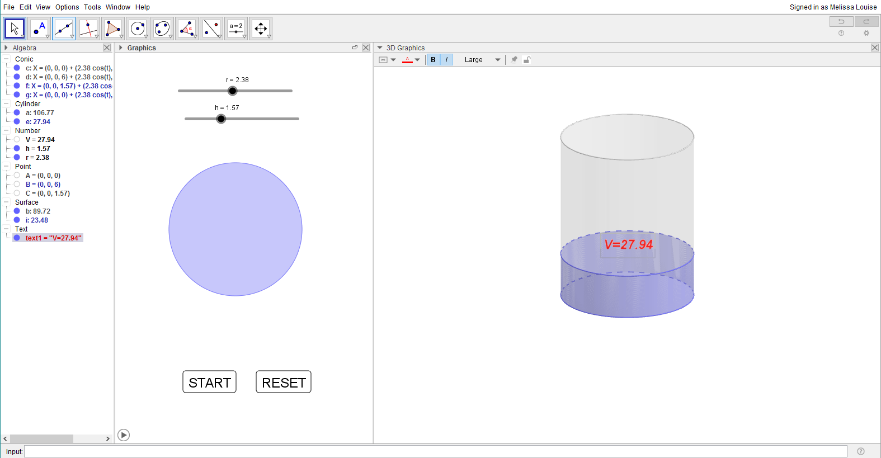

Questions
- When h remains constant, explain how changing the value of r affect the volume of the cylinder.

- When r remains constant, explain how changing the value of h affect the volume of the cylinder.

- State the volume of a cylinder, based on the following restriction.

  - r = 30 , h=5.01
  - r = 25 , h=1.26
  - r = 45 , h=2.6
  - r = 15 , h=3.1
  - r = 28 , h=5.6
  - r = 6 , h=90

Extension Activity

- We learned about two other formulas relating to the volume of a solid, including a prism and a cone. Following the steps that we used to find the volume of a cylinder in Geogebra, design and demonstrate how to create an animation representing the volume of either a prism or a cone.

Resources

[Svijet Matematike]. (2016, June 14). Volume of a cylinder (animated) in Geogebra [tutorial]. [Video File]. Retrieved from https://www.youtube.com/watch?v=wEKAGGB4Mng&t=97s

